IN404 Unit 7 Assignment: Pipeline Models
Shubham Raj
Purdue University Global
IN404: Machine Learning
Dr. Sen Baidya
November 2, 2026

Item 1: Python Code and Execution Results
I saved the provided IN404_Reviews.csv file and the three starter programs together in my Unit 7 Assignment folder and completed every section marked "YOUR CODE HERE." I then ran the whole application with a single command, python3 IN404_Unit7_Driver.py, which uses subprocess.run to run IN404_Unit7_1.py and IN404_Unit7_2.py (Python Software Foundation, n.d.). The code I added does the following:
- IN404_Unit7_1.py: Creates the reviews_best_worst DataFrame, which removes the 3-star (neutral) reviews; prints the parameter grid; builds a GridSearchCV object around the pipeline with cv=5 and scoring='accuracy'; fits it on the review text and the score column; and prints grid.best_score_ and grid.best_params_.
- IN404_Unit7_2.py: Creates sentiment_range with np.arange(-1.0, 1.05, 0.05), prints sentiment_range[:100], builds the list of RMSE values by calling sentiment_split for every cutpoint, and plots the sentiment cutpoint versus RMSE line chart with plt.plot (McGreggor, 2015).
- IN404_Unit7_Driver.py: Runs both programs with subprocess.run and shell=True. The starter comment suggested joining the two commands with a single &. I used && instead, because on macOS a single & sends the first program to the background, so both programs run at the same time and their output can mix together. With &&, the second program starts only after the first one finishes successfully. I also used sys.executable so that both programs run with the same Python interpreter as the driver (my virtual environment), and I set cwd to the driver's folder so that both programs can find IN404_Reviews.csv no matter where I start the driver from.

Complete Python Code (IN404_Unit7_1.py)
import pandas as pd
import numpy as np
import scipy as sp
from sklearn.pipeline import Pipeline, FeatureUnion, make_pipeline, make_union
from sklearn.feature_extraction.text import CountVectorizer, TfidfVectorizer
from sklearn.linear_model import LogisticRegression
from textblob import TextBlob, Word
from sklearn.naive_bayes import MultinomialNB
from sklearn.model_selection import GridSearchCV
import matplotlib.pyplot as plt
from sklearn.model_selection import train_test_split, cross_val_score
from sklearn import metrics
import sys
#Ignoring warnings
if not sys.warnoptions:
import warnings
warnings.simplefilter("ignore")
#Set the writeFunction boolean
#True = write to console
#False = write to file for assignment turnin
PRINT = True
#Open a file handle for assignment results.
if PRINT == False:
f = open("IN404_Unit7_1.txt", "a")
###############################################
##
##PURPOSE: Write to console or file based on
## the writeFunction variable
## True = write to concole
## False = write to file for assignment turnin
##
##INPUT: Message to write (message1)
## Optional: message2
##
##OUTPUT: None
##
###############################################
def writeFunction(message1, *message2):
#Print to console
if PRINT:
print(message1)
print(message2)
print()
#Print to file for assignment
else:
f.write(str(message1))
f.write(str(message2))
f.write("\n\n")
#Read IN404_Reviews.csv into a DataFrame
reviews = pd.read_csv('IN404_Reviews.csv', encoding='unicode-escape')
#Set values as NaN to none
reviews.replace(['NaN', np.nan], 'none', inplace=True)
#Add a score column
reviews['score'] = np.where(reviews.Star > 3, 1, 0)
#Create new dataframe eliminating rows without reviews
new_reviews = reviews[(reviews.Review_Text != 'none')]
#Create a new DataFrame called reviews_best_worst that removes 3-star ratings
reviews_best_worst = new_reviews[new_reviews.Star != 3]
#Pipeline example using GridSearchCV
pipe = Pipeline([
('features', FeatureUnion([
#With count vectorization
('counts', CountVectorizer()),
#With TF-IDF
('tf_idf', TfidfVectorizer())
])),
#With Multinomial Naive Bayes classification
('classifier', MultinomialNB())
])
#Find best n_neighbors value using GridSearchCV
gram_range = [(1, n) for n in range(1, 5)]
param_grid = {
'features__counts__ngram_range': gram_range,
'features__tf_idf__ngram_range': gram_range,
}
#Print the grid
writeFunction("Parameters for the grid", param_grid)
#Get the accuracy score of the pipelined model
# Use cross validation of 5 and scoring to accuracy
grid = GridSearchCV(pipe, param_grid, cv=5, scoring='accuracy')
#Fit the data set without 3-star ratings
# for Reviews_Test and score
grid.fit(reviews_best_worst.Review_Text, reviews_best_worst.score)
#Print the grid's best score
writeFunction("Grid best score", grid.best_score_)
#Print the grid's best parameter
writeFunction("Grid best parameter", grid.best_params_)

Complete Python Code (IN404_Unit7_2.py)
import pandas as pd
import numpy as np
import scipy as sp
from sklearn.pipeline import Pipeline, FeatureUnion, make_pipeline, make_union
from sklearn.feature_extraction.text import CountVectorizer, TfidfVectorizer
from sklearn.linear_model import LogisticRegression
from textblob import TextBlob, Word
from sklearn.naive_bayes import MultinomialNB
from sklearn.model_selection import GridSearchCV
import matplotlib.pyplot as plt
from sklearn.model_selection import train_test_split, cross_val_score
from sklearn import metrics
import sys
#Ignoring warnings
if not sys.warnoptions:
import warnings
warnings.simplefilter("ignore")
#Set the writeFunction boolean
#True = write to console
#False = write to file for assignment turnin
PRINT = True
#Open a file handle for assignment results.
if PRINT == False:
f = open("IN404_Unit7_2.txt", "a")
###############################################
##
##PURPOSE: Write to console or file based on
## the writeFunction variable
## True = write to concole
## False = write to file for assignment turnin
##
##INPUT: Message to write (message1)
## Optional: message2
##
##OUTPUT: None
##
###############################################
def writeFunction(message1, *message2):
#Print to console
if PRINT:
print(message1)
print(message2)
print()
#Print to file for assignment
else:
f.write(str(message1))
f.write(str(message2))
f.write("\n\n")
#Read IN404_Reviews.csv into a DataFrame
reviews = pd.read_csv('IN404_Reviews.csv', encoding='unicode-escape')
#Replace NaN values with none
reviews.replace(['NaN', np.nan], 'none', inplace=True)
#Define a function that accepts text and returns the polarity
def detect_sentiment(text):
return TextBlob(text).sentiment.polarity
#Add a new DataFrame column for sentiment
reviews['sentiment'] = reviews.Review_Text.apply(detect_sentiment)
#Find reviews with none
dt_reviews = reviews[(reviews.Review_Text != 'none')]
#Create a prediction column using the mean
dt_reviews['prediction'] = dt_reviews.sentiment.mean()
#Calculate RMSE for those predictions (uses sentiment and prediction)
writeFunction("RMSE for sentiments and predictions", np.sqrt(metrics.mean_squared_error(dt_reviews.sentiment, dt_reviews.prediction)))
#Define a function that calculates the RMSE for a given split of sentiment
def sentiment_split(sentiment):
#Calculate the mean Star for sentiment under the sentiment split
lower_sentiment_star = dt_reviews[dt_reviews.sentiment < sentiment].Star.mean()
#Calculate the mean Star for sentiment above the sentiment split
higher_sentiment_star = dt_reviews[dt_reviews.sentiment >= sentiment].Star.mean()
#Slice the prediciotn column with mean star for sentiment
dt_reviews['prediction'] = np.where(dt_reviews.sentiment < sentiment, lower_sentiment_star, higher_sentiment_star)
#Return the RMSE using Star and prediction values
RMSE = np.sqrt(metrics.mean_squared_error(dt_reviews.Star, dt_reviews.prediction))
return RMSE
#Check sentiment splits using np.arange
# with range from -1.0 to 1.05 and a scale of 0.05
# Call the variable sentiment _range
sentiment_range = np.arange(-1.0, 1.05, 0.05)
#Print the sentiment range [:100]
writeFunction("Sentiment range", sentiment_range[:100])
#Get the RMSE value list
RMSE = [sentiment_split(sentiment) for sentiment in sentiment_range]
#Plot a line chart using the sentiment cutpoint versus RMSE
plt.plot(sentiment_range, RMSE)
plt.xlabel('Sentiment cutpoint')
plt.ylabel('RMSE (lower is better)')
plt.show()

Complete Python Code (IN404_Unit7_Driver.py)
import subprocess
#Run the subprocess.run command with the two file path and names
# python3 IN404_Unit7_1.py & python3 IN404_Unit7_2.py.
#
# As well as shell=True
# Easiest if the files are all in the same directory or folder
import sys
from pathlib import Path
#Use the same Python interpreter that runs this driver, and run from this
# file's folder so both programs can find IN404_Reviews.csv.
#&& runs the programs one after the other so their output does not interleave.
PYTHON = f'"{sys.executable}"'
subprocess.run(f"{PYTHON} IN404_Unit7_1.py && {PYTHON} IN404_Unit7_2.py",
shell=True, cwd=Path(__file__).resolve().parent)

Execution Screenshots
These screenshots are from running IN404_Unit7_Driver.py in the VS Code terminal with my virtual environment. Figure 1 shows the whole run: the driver code, the line chart window that IN404_Unit7_2.py opened, and the terminal output. Figures 2 and 3 are close-ups of the chart and the output.
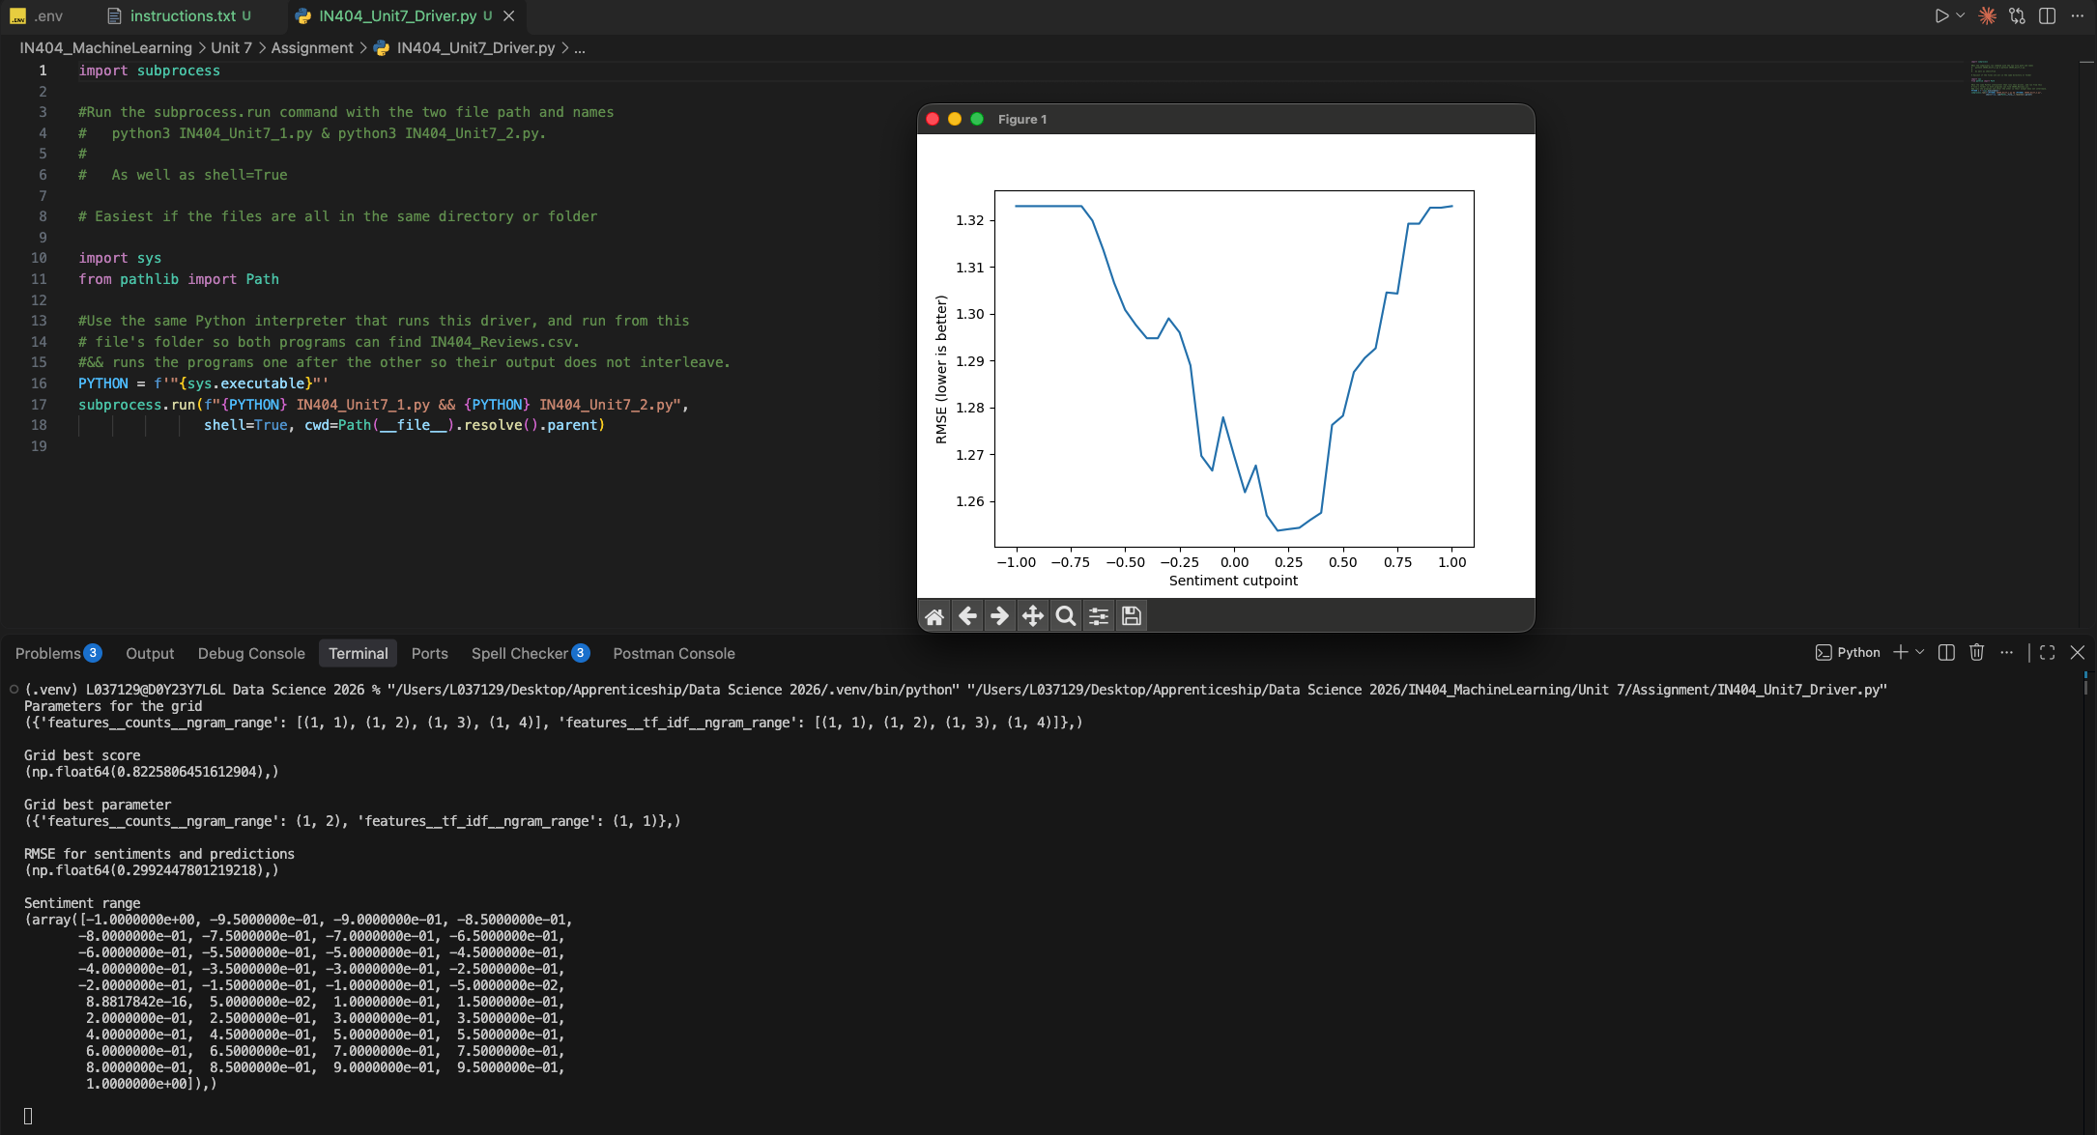
Figure 1: Running IN404_Unit7_Driver.py, showing the driver code, the line chart window, and the terminal output.
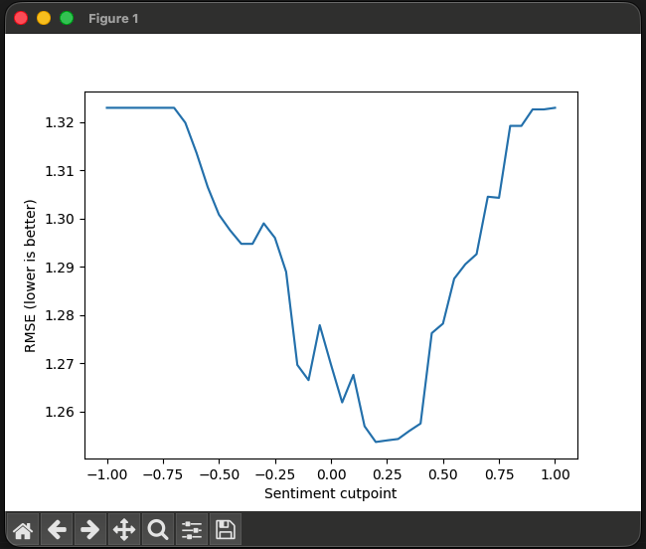
Figure 2: Sentiment cutpoint versus RMSE line chart produced by IN404_Unit7_2.py.
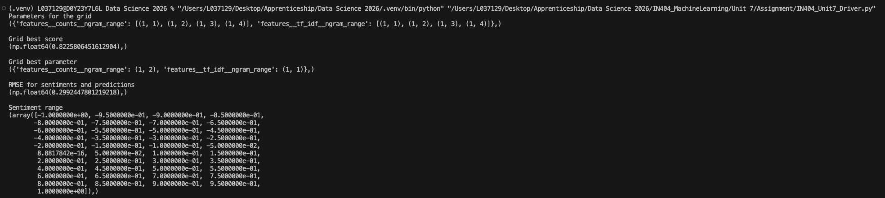
Figure 3: Terminal output from the same run (the full console text follows below).

Console Output
The first three results come from IN404_Unit7_1.py, and the last two come from IN404_Unit7_2.py.
Parameters for the grid
({'features__counts__ngram_range': [(1, 1), (1, 2), (1, 3), (1, 4)], 'features__tf_idf__ngram_range': [(1, 1), (1, 2), (1, 3), (1, 4)]},)
Grid best score
(np.float64(0.8225806451612904),)
Grid best parameter
({'features__counts__ngram_range': (1, 2), 'features__tf_idf__ngram_range': (1, 1)},)
RMSE for sentiments and predictions
(np.float64(0.2992447801219218),)
Sentiment range
(array([-1.0000000e+00, -9.5000000e-01, -9.0000000e-01, -8.5000000e-01,
-8.0000000e-01, -7.5000000e-01, -7.0000000e-01, -6.5000000e-01,
-6.0000000e-01, -5.5000000e-01, -5.0000000e-01, -4.5000000e-01,
-4.0000000e-01, -3.5000000e-01, -3.0000000e-01, -2.5000000e-01,
-2.0000000e-01, -1.5000000e-01, -1.0000000e-01, -5.0000000e-02,
8.8817842e-16, 5.0000000e-02, 1.0000000e-01, 1.5000000e-01,
2.0000000e-01, 2.5000000e-01, 3.0000000e-01, 3.5000000e-01,
4.0000000e-01, 4.5000000e-01, 5.0000000e-01, 5.5000000e-01,
6.0000000e-01, 6.5000000e-01, 7.0000000e-01, 7.5000000e-01,
8.0000000e-01, 8.5000000e-01, 9.0000000e-01, 9.5000000e-01,
1.0000000e+00]),)

Item 2: IN404_Unit7_1.py Results

What was the best score?
The best score was 0.8226 (about 82.3%). This is the mean accuracy across the five cross-validation folds for the best of the 16 parameter combinations. In other words, the best pipeline correctly labeled about 82% of the held-out reviews as positive or negative.
To judge whether this is a good result, I compared it to a simple baseline. After the reviews without text and the 3-star reviews are removed, reviews_best_worst contains 310 reviews: 233 positive (4 or 5 stars) and 77 negative (1 or 2 stars). A model that always guessed "positive" would be right 75.2% of the time, so the pipeline improves on that baseline by about 7 percentage points. The improvement is real but modest, which makes sense for a small dataset of short app reviews.

What was the best parameter setting?
The best parameter setting was {'features__counts__ngram_range': (1, 2), 'features__tf_idf__ngram_range': (1, 1)}. This means the CountVectorizer worked best with single words plus two-word phrases, while the TfidfVectorizer worked best with single words only.
I think this combination makes sense. The two-word phrases in the count features let the model capture short phrases such as "not good" or "very helpful," where the meaning depends on the word pair, while the single-word TF-IDF features add weighted vocabulary information without repeating the phrase features. Three- and four-word phrases did not help, probably because most specific phrases of that length appear in only one or two of the 310 reviews, so the model cannot learn anything general from them. When I compared all 16 settings in grid.cv_results_, I also noticed that the top settings were very close. The best score of 0.8226 equals 255 of 310 reviews labeled correctly, while the second-best score of 0.8129 equals 252, a difference of only three reviews. So I would treat this as the best setting for this dataset, but not as a large or guaranteed improvement over the others.

Item 3: IN404_Unit7_2.py Results

What was the RMSE sentiment score?
The RMSE sentiment score was 0.2992 (about 0.30).
For this calculation, the program predicted the same value for every review: the mean polarity of 0.2225. The RMSE of 0.30 therefore tells me how far a typical review's polarity is from that average. Because the prediction is the mean, this RMSE is the same as the standard deviation of the polarity scores. On TextBlob's polarity scale, which runs from -1.0 to 1.0 (Loria, n.d.), a typical review is about 0.30 above or below the average, so the reviews are mildly positive on average but vary quite a bit. I see this value as a baseline: any model that tries to predict a review's sentiment would need an RMSE below 0.30 to do better than simply guessing the average.

What is the lowest value in the sentiment range?
The lowest value in the sentiment range is -1.0.

What is the highest value in the sentiment range?
The highest value in the sentiment range is 1.0.
np.arange(-1.0, 1.05, 0.05) starts at -1.0, steps by 0.05, and stops before 1.05, so it produces 41 cutpoints from -1.0 to 1.0. Because there are fewer than 100 values, sentiment_range[:100] printed the whole array. The middle value prints as 8.88e-16 instead of 0 because adding 0.05 over and over creates a tiny floating-point rounding error, but it is effectively zero. These cutpoints cover the full polarity scale, but the actual polarity scores in the data only range from -0.66 to 1.0. That is why the line chart is flat from -1.0 to about -0.70: no review falls below those cutpoints, so every review ends up in the same group.

What the line chart shows
Figure 2 plots the RMSE of the star-rating predictions at each cutpoint. For each cutpoint, sentiment_split predicts the average star rating of the reviews below the cutpoint for those reviews, and the average star rating of the reviews at or above the cutpoint for the rest. The lowest RMSE, about 1.254, occurs at a cutpoint of 0.20. At that cutoff, the 190 reviews below 0.20 average 3.32 stars and the 173 reviews at or above it average 4.16 stars, so 0.20 is the best sentiment cutoff for separating lower-rated from higher-rated reviews.
However, the RMSE only drops from 1.323 (no useful split) to 1.254, about a 5% improvement. This RMSE is measured in stars on a 1-to-5 scale, not in polarity units, so it cannot be compared directly with the 0.30 score above. It means a typical prediction is still about 1.25 stars off, which tells me that polarity alone is only a weak predictor of a review's star rating. This matches what we saw in earlier units, where some reviews with positive words still received low star ratings.

Item 4: The Value of Using a Driver to Run Several Programs
A driver program is a small program whose only job is to start other programs in the right order. In my IN404_Unit7_Driver.py, one subprocess.run call starts IN404_Unit7_1.py and then IN404_Unit7_2.py. subprocess.run waits for the command to finish and then returns a CompletedProcess object that includes the return code (Python Software Foundation, n.d.). I see five main benefits to this approach:
- One command runs everything: Instead of opening and running each file separately, I run one file and get every result. This saves time and avoids forgetting a step.
- Consistent, repeatable runs: The driver always runs the programs in the same order, with the same interpreter and folder, so anyone who reruns my work follows exactly the same process. This is important for reproducing results.
- Modular code: Each program keeps one focused job: model tuning in one and sentiment analysis in the other. I can still run, test, or fix each file on its own, while the driver combines them into one application.
- Separate processes: Each program runs in its own process with its own memory, so variables in one program cannot accidentally affect the other. If one program fails, its return code shows which step failed, and with && the driver does not start the next step.
- Easy to scale and automate: Adding a third or fourth program only means adding it to the command, and the driver itself can be scheduled to run automatically, for example every night when new reviews arrive.
One caution I learned while researching subprocess is that shell=True passes the command through the system shell, so the Python documentation warns that the program is responsible for quoting the command correctly to avoid shell injection (Python Software Foundation, n.d.). This is safe in my driver because the file names are fixed in the code, but I would avoid building the command from user input.

Item 5: Grid Search Functionality in Python

Pipeline and the value of using it
A scikit-learn Pipeline chains several processing steps and a final estimator into a single object (scikit-learn developers, n.d.-c). In my IN404_Unit7_1.py, the pipeline has two steps. The first is a FeatureUnion that turns each review into numbers with both CountVectorizer and TfidfVectorizer and joins the two sets of features. The second is a MultinomialNB classifier that makes the final positive or negative decision. The pipeline behaves like one model: calling fit() runs every step on the training data, and calling predict() runs the same steps on new reviews (Pedregosa et al., 2011).
The scikit-learn documentation describes three main benefits of using a pipeline (scikit-learn developers, n.d.-c):
- Convenience and encapsulation: I only call fit and predict once for the whole sequence, instead of transforming the data by hand at each step.
- Joint parameter selection: I can grid search the settings of every step at once. The double-underscore names in my parameter grid, such as features__counts__ngram_range, tell GridSearchCV to go into the features step, then the counts tool, and then its ngram_range setting.
- Safety: Inside cross-validation, the vectorizers are fit on the training folds only, so vocabulary and word weights from the held-out fold never leak into training. Without a pipeline, it is easy to vectorize the whole dataset first, which makes the cross-validation score look better than the model really is.

Multinomial Naïve Bayes classifier
Multinomial Naïve Bayes is a probabilistic classifier based on Bayes' theorem, which updates the probability of a class based on the evidence observed (Ozdemir, 2016). For text, the evidence is the words in a review. During training, the model learns how often each word appears in each class. For a new review, it combines those word probabilities to estimate which class is more likely (Manning et al., 2008).
The classifier is called "naive" because it assumes that every feature is independent of the others once the class is known (scikit-learn developers, n.d.-b). In a review, this means each word votes on its own, even though words such as "not" and "good" clearly depend on each other. This is why n-grams help: once "not good" is counted as one feature, the model treats it as one vote. The term "multinomial" refers to the type of data the model expects, which is counts of how often each word occurs, so a word that appears twice gives stronger evidence than a word that appears once. The scikit-learn documentation notes that MultinomialNB is one of the two classic Naïve Bayes variants used for text classification and that TF-IDF vectors also work well with it in practice, which is why my pipeline can feed it both counts and TF-IDF values (scikit-learn developers, n.d.-b). It also uses a smoothing parameter, alpha, which defaults to 1.0 (Laplace smoothing), so that a word never seen in one class during training does not produce a probability of zero. Multinomial Naïve Bayes suits this assignment because it trains very quickly and handles the large number of word features that text creates (Manning et al., 2008).

GridSearchCV and what it offers for machine learning
GridSearchCV performs an "exhaustive search over specified parameter values for an estimator" (scikit-learn developers, n.d.-a). I give it a model (my pipeline), a parameter grid (a dictionary of settings to try), a cross-validation setting, and a scoring method. It then trains and scores the model for every combination in the grid and keeps the combination with the best average score. In my program, the grid had 4 n-gram options for the count features and 4 for the TF-IDF features, so it tested 4 × 4 = 16 combinations. With cv=5, each combination was trained and tested five times on different splits, for 80 fits in total, plus one final fit of the best setting on the full dataset. GridSearchCV offers the following:
- Systematic tuning: It replaces trial and error with a complete, repeatable search, so I know every setting in the grid was tested in the same way.
- More reliable scores: Because each setting is scored with cross-validation instead of a single train/test split, the result is less likely to depend on a lucky or unlucky split.
- A ready-to-use model: With the default refit=True, GridSearchCV retrains the best setting on the whole dataset, so the grid object can make predictions right away (scikit-learn developers, n.d.-a).
- Easy comparison: The cv_results_ attribute stores the scores for every combination and can be loaded into a pandas DataFrame, which is how I compared the top settings in Item 2.
The main limitation is cost. The number of fits multiplies with every parameter added, so a larger grid quickly becomes slow. Bergstra and Bengio (2012) showed that randomly sampling settings is often more efficient than an exhaustive grid when only a few parameters really matter, and scikit-learn offers RandomizedSearchCV for that approach.

The best_score_ and best_params_ parameters
After fitting, GridSearchCV stores its results in attributes that end with an underscore. The two used in my program are:
- best_score_: The mean cross-validated score of the best estimator (scikit-learn developers, n.d.-a). Because my scoring was 'accuracy', my best_score_ of 0.8226 is the average accuracy of the best setting across the five held-out folds. It is an estimate of how well the model should perform on reviews it has not seen.
- best_params_: A dictionary of the parameter setting that gave the best results on the held-out data (scikit-learn developers, n.d.-a). Mine was {'features__counts__ngram_range': (1, 2), 'features__tf_idf__ngram_range': (1, 1)}. The keys use the same step__tool__parameter names as the parameter grid, so the result shows exactly which step each winning setting belongs to.
Two related attributes are best_estimator_, which is the refit pipeline that uses the best_params_ settings, and cv_results_, which holds the scores for every combination. One thing I keep in mind is that best_score_ comes from the same data used to choose the parameters, so it can be slightly optimistic. For a final estimate of performance, I would also keep a separate test set that the grid search never sees.

References
Bergstra, J., & Bengio, Y. (2012). Random search for hyper-parameter optimization. Journal of Machine Learning Research, 13, 281–305. https://jmlr.org/papers/v13/bergstra12a.html
Loria, S. (n.d.). Tutorial: Quickstart. TextBlob documentation. Retrieved November 2, 2026, from https://textblob.readthedocs.io/en/dev/quickstart.html
Manning, C. D., Raghavan, P., & Schütze, H. (2008). Introduction to information retrieval. Cambridge University Press.
McGreggor, D. M. (2015). Mastering matplotlib. Packt Publishing.
Ozdemir, S. (2016). Principles of data science. Packt Publishing.
Pedregosa, F., Varoquaux, G., Gramfort, A., Michel, V., Thirion, B., Grisel, O., Blondel, M., Prettenhofer, P., Weiss, R., Dubourg, V., Vanderplas, J., Passos, A., Cournapeau, D., Brucher, M., Perrot, M., & Duchesnay, E. (2011). Scikit-learn: Machine learning in Python. Journal of Machine Learning Research, 12, 2825–2830. https://jmlr.org/papers/v12/pedregosa11a.html
Python Software Foundation. (n.d.). subprocess — Subprocess management. Python documentation. Retrieved November 2, 2026, from https://docs.python.org/3/library/subprocess.html
scikit-learn developers. (n.d.-a). GridSearchCV. scikit-learn documentation. Retrieved November 2, 2026, from https://scikit-learn.org/stable/modules/generated/sklearn.model_selection.GridSearchCV.html
scikit-learn developers. (n.d.-b). Naive Bayes. scikit-learn documentation. Retrieved November 2, 2026, from https://scikit-learn.org/stable/modules/naive_bayes.html
scikit-learn developers. (n.d.-c). Pipelines and composite estimators. scikit-learn documentation. Retrieved November 2, 2026, from https://scikit-learn.org/stable/modules/compose.html

